**Summit Station Weekly Science Report**

**Reporting Period:**  January 7, 2018 – January 13, 2019

**Completed by:** Gus Allen, Troy Nave

**Comments:** Extremely low ambient temperatures prevented the techs from performing several routine tasks this week.

Wind speeds at Summit ranged from 0.0 m/s, recorded on 2019-1-10, to 19.7 m/s on 2019-1-8. The average wind speed for the week was 7.71 m/s. Temperatures ranged from a low of -61.0˚C on 2019-1-10 to a high of -22.26˚C on 2019-1-9. The average temperature was -46.66˚C.

Summit experienced low winds from 1529 to 1752 Z on 2019-1-10. North winds were experienced at Summit intermittently from 1429 to 1627 Z on 2019-1-10.

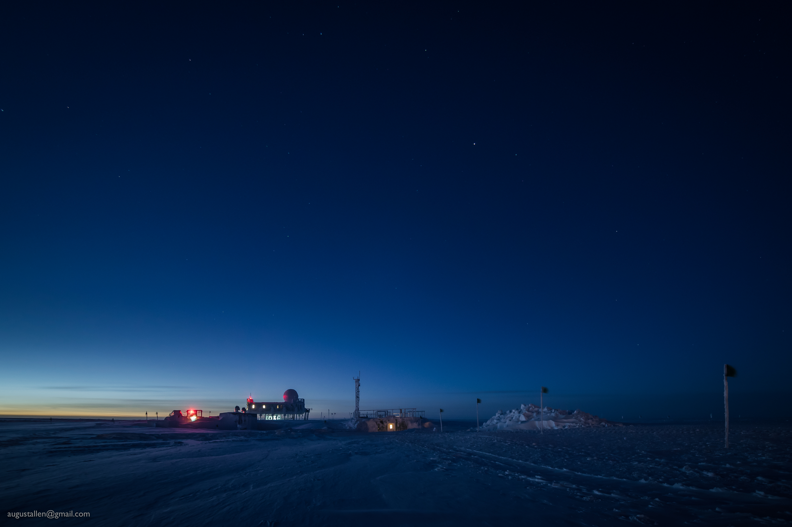

While the sun remains below the horizon for another two weeks, the twilight glow at local noon is noticeably brighter.

**Please visit the clean air log at ftp://isr.sri.com/pub/summit/ftp/science/clean_air_traffic/**

|  |  |
| --- | --- |
| **Facilities** | **Comment** |
| TAWO | Interior door lock stuck, but tech is able to enter building. |
| MSF | MMCR level 0.11 pitch 0.00 roll |
| Green House |  |
| **Experiment** | **Notes** |
| NOAA CCGG flasks | Comment:  Date performed: 2019-1-10 |
| NOAA HATS flasks | Comment:  Date performed: 2019-1-8 |
| NOAA Surface Ozone | Comment: Calibrated on 2019-1-8.  % of time operating: 100% |
| NOAA Aethelometer | Comment: Instrument offsite for service.  % of time operating: 0% |
| NOAA Meteorology | Comment:  % of time operating: 100% |
| NOAA CLAP & Neph | Comment: Span check completed 2019-1-8  % of time operating: 100% |
| Radionuclide Filter | Comment: Changed every other day  % of time operating: 100% |
| Aerosol DRUM Sampler | Comment:  % of time operating: 100% |
| Bamboo Forest | Comment: Not completed due to condition 1 temps (-58 C)  Date performed: 2019-1-4 |
| SnowFox | Comment:  Date performed: 2019-1-9 |
| ICESat Accumulation | Comment:  Date performed: 2018-12-15 |
| GFZ Potsdam Seismometer | Comment:  % of time operating: 100% |
| DTU Magnetometer | Comment:  % of time operating: 100% |
| UNAVCO | Comment: |
| Helmig CUGC | Comment:  % of time operating: 100% |
| Steffen Tower Instruments | Comment:  % of time operating: 100% |
| Steffen Solar Instruments | Comment:  % of time operating: 100% |
| ICECAPS-ACE Total Sky Imager | Comment: Offline for the winter.  % of time operating: 0% |
| ICECAPS-ACE Radiosonde | Comment:  Dates performed: Twice daily. |
| ICECAPS-ACE MWR | Comment:  % of time operating: 100% |
| ICECAPS-ACE SODAR | Comment:  % of time operating: 100% |
| ICECAPS-ACE POSS | Comment:  % of time operating: 100% |
| ICECAPS-ACE MASC | Comment: Instrument offsite for service; expected return 2019-06.  % of time operating: 0% |
| ICECAPS-ACE MMCR | Comment:  % of time operating: 100% |
| ICECAPS-ACE CAPABL | Comment: On 1-8 the laser was powered down because of snow over the window. Instrument is presently operating normally using laser 2.  % of time operating: 99% |
| ICECAPS-ACE MPL | Comment:  % of time operating: 100% |
| ICECAPS-ACE Ceilometer | Comment:  % of time operating: 100% |
| ICECAPS-ACE PAERI | Comment:  % of time operating: 100% |
| ICECAPS-ACE IcePIC | Comment: No images captured this week.  Date(s) performed: |
| ICECAPS-ACE CLASP | Comment: Instrument offsite for service; expected return 2019-02.  % of time operating: 0% |
| ICECAPS-ACE CPC | Comment: Instrument offsite for service; expected return 2019-02.  % of time operating: 0% |
| ICECAPS-ACE OPC | Comment: OPC was repowered and data collection started on 1-9 16Z. Data is currently being stored locally as the connection with ICECAPS Dataman has not yet been restored.  % of time operating: ~65% |
|  |  |  |
|  |  |  |